**BI Concepts, Tools and Applications : Summative Project**

**Qn1:**

*Analysis of all the visualizations with respect to how it is helping you find the Key Performance Indicators and the causes of various problems identified.*

* These virtualizations have led me it identifies the following KPI
  1. With the revenue contribution for each of the three location on the first quarter of year there is clear turn around after the first month where B.B. Brooklyn maintained almost the same revenue, with clear revenue drop on B.B Lower Manhattan. It’s only the B.B upper West should revenue incremental which is good thing

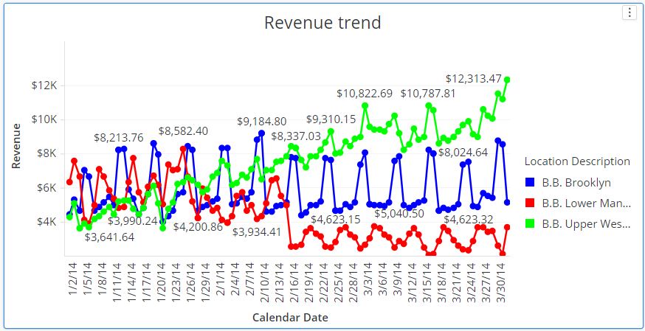

Some of the reason:

* The location of B.B Lower Manhattan and B.B. Brooklyn need to be revised.
* Promotion that were run only in the first month on all location should continue both B.B Lower Manhattan and B.B. Brooklyn
* Despite the revenue difference between the location, all the three locations seem to attain below the average score line of 28 with lower Manhattan location improving the score toward end of the Quarter

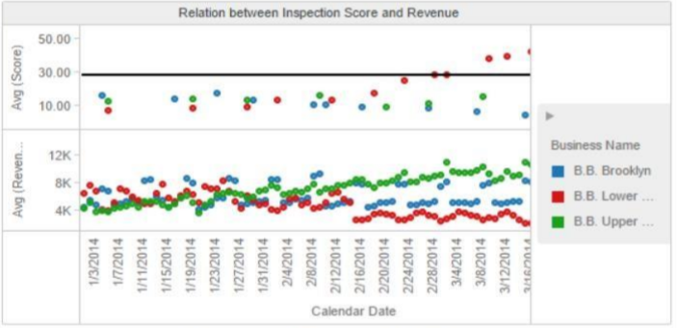

**Qn2**

*What more could you have done other than what is included in the exercise to achieve better analysis of both the datasets?*

* Would do segmentation of products to understand the contribution of each product on the total revenue daily

